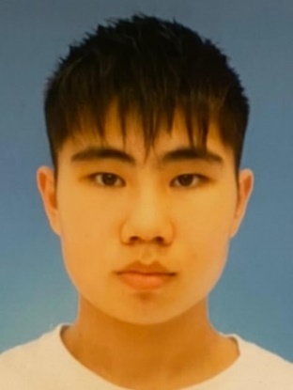
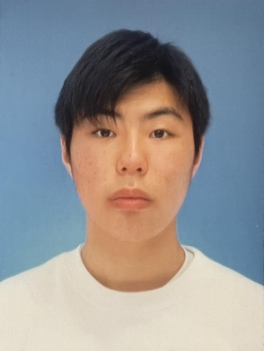
Toma Kasahara Koga Kamii Kaho Sakai Takumi Mizuno
Shinmachi Shinmachi Shinmachi Shinmachi
age: 18 (M) age: 19 (M) age: 18 (F) age: 17 (M)
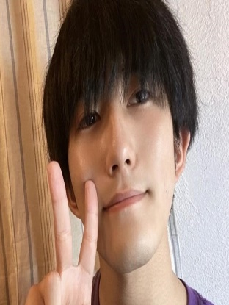
Haruhi Kotegawa Chiharu Takizawa Yui Nakao Saki Haruyama
Shinmachi Shinmachi Shinmachi Shinmachi
age: 17 (M) age:15 (F) age: 15 (F) age: 15 (F)
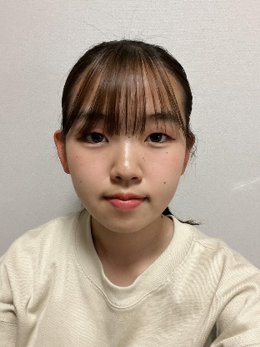
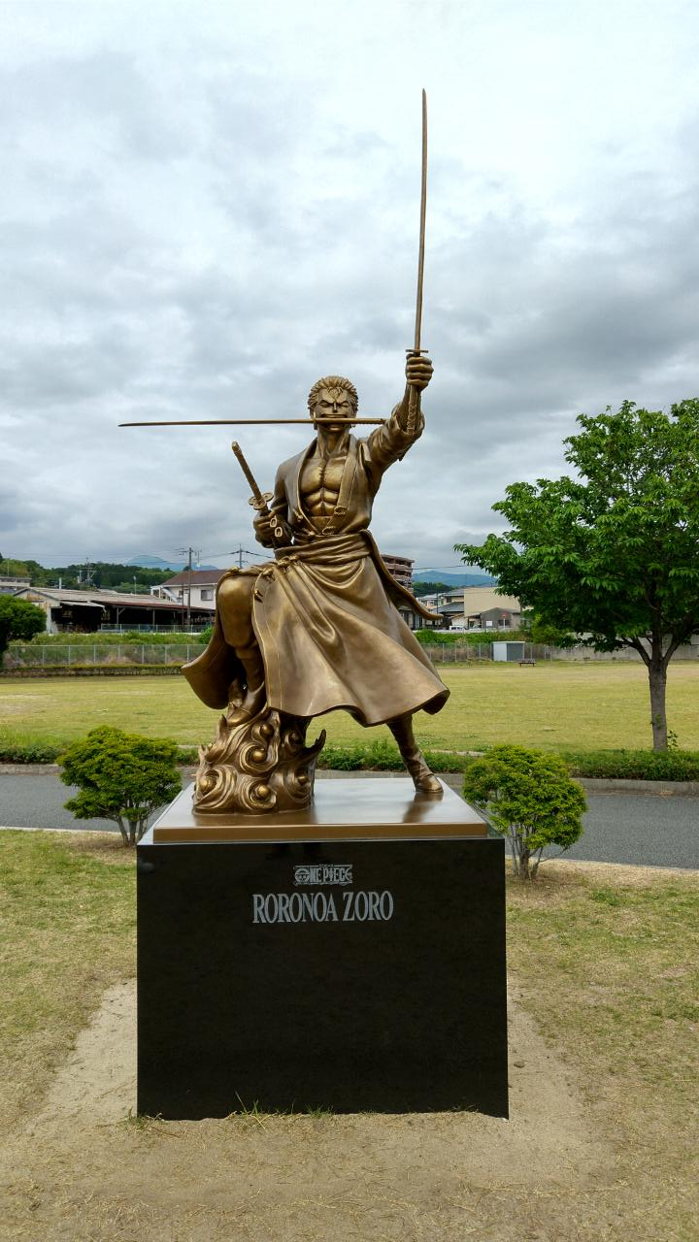
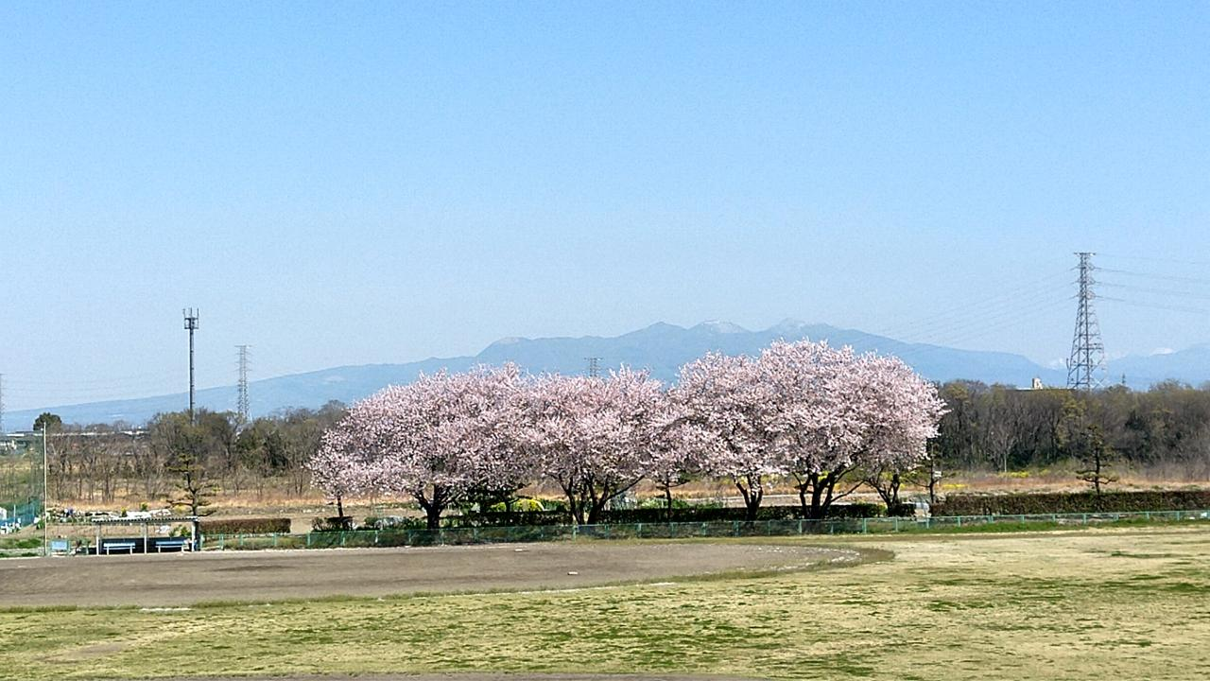
Rin Sagae
Shinmachi Shinmachi
age: 18 (F) Ozu
Ryoka Takaki Riko Saito Mizuki Higashi Haruna Tokunaga
Ozu Ozu Ozu Ozu
age: 23 (F) age: 24 (F) age: 21 (F) age: 18 (F)

8th Nürnberg ＆ Shinmachi/Ozu
Youth international exchange
(05-16.08.2022)

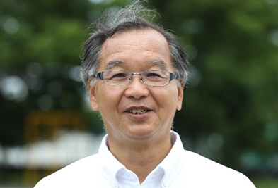
Toshikazu Koide(Shinmachi)
age: 64 (M)
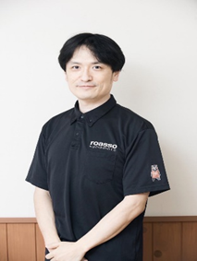
Takumu Tomita Miku Todo Shuichiro Higuchi
Shinmachi Shinmachi Ozu
age: 29 (M) age: 20 (F) age: 44 (M)
Shinmachi
Takasaki
GUNMA
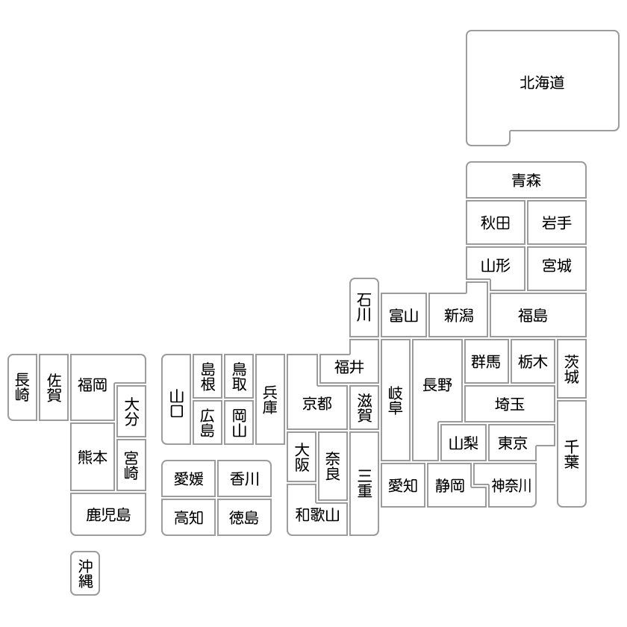
Ozu-machi
Kikuchi-Gun
KUMAMOTO

